Detailed design

5.1: Introduction

Detailed design, also known as low-level design, refers to the process of elaborating and specifying the components, modules, and interactions of a system or software solution. It involves translating the high-level design into a more detailed and implementation-oriented representation, providing instructions for developers to construct the system.

5.2: Structure of Software Package

* Structure of admin module

admin

login

View patient

Manage report

Manage payment

View feedback

View doctor

* Structure of doctor module

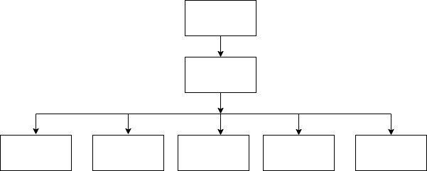

* Structure of patient module

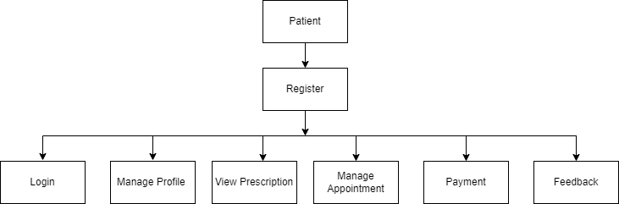

5.3: Modular decomposition of the System

5.3.1: Module 1

5.3.1.1: Inputs

5.3.1.2: Procedural Details

5.3.1.3: File I/O interfaces

5.3.1.4: Outputs

5.3.1.5: Implementation Aspects

5.3.2: Module 2

5.3.2.1: Inputs

5.3.2.2: Procedural Details

5.3.2.3: File I/O interfaces

5.3.2.4: Outputs

5.3.2.5: Implementation Aspects